**WEEK 1: Design Patterns and Principles (Solutions)**

**Exercise 1: Implementing the Singleton Pattern**

**Scenario:**

You need to ensure that a logging utility class in your application has only one instance throughout the application lifecycle to ensure consistent logging.

**Steps:**

1. **Create a New Java Project:**
   * Create a new Java project named **SingletonPatternExample**.
2. **Define a Singleton Class:**
   * Create a class named Logger that has a private static instance of itself.
   * Ensure the constructor of Logger is private.
   * Provide a public static method to get the instance of the Logger class.

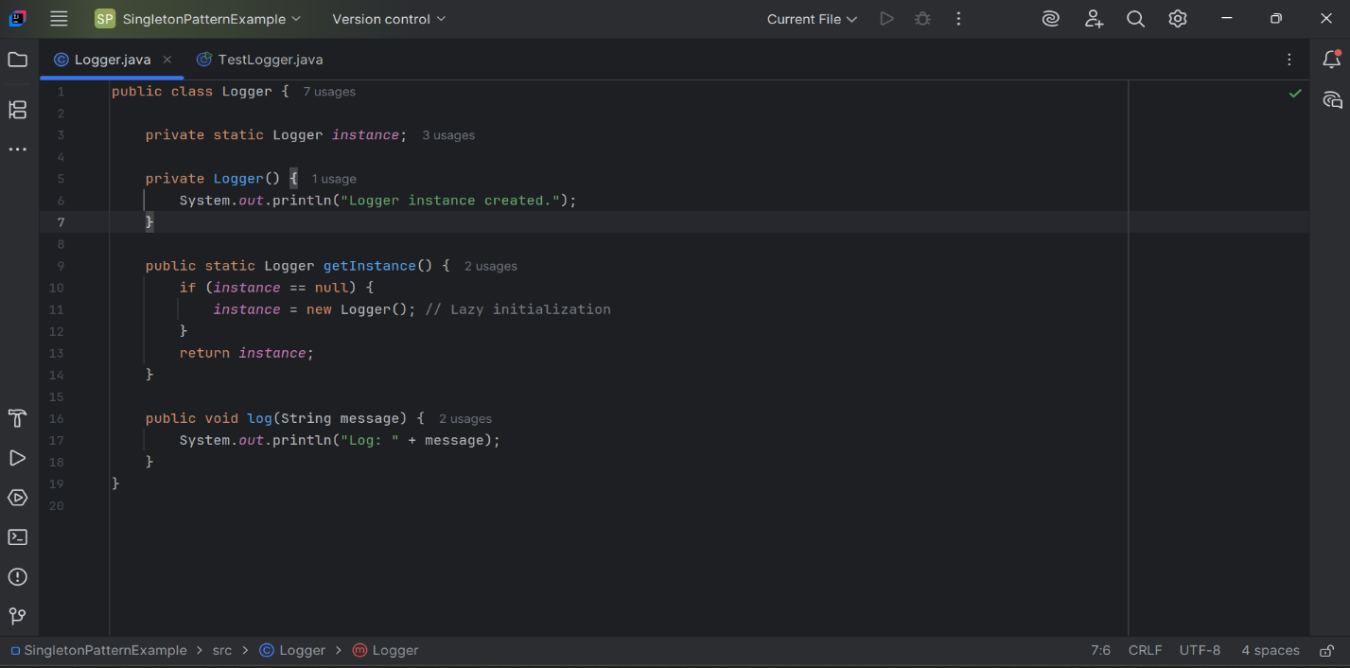

1. **Implement the Singleton Pattern:**
   * Write code to ensure that the Logger class follows the Singleton design pattern.
2. **Test the Singleton Implementation:**

* Create a test class to verify that only one instance of Logger is created and used across the application.

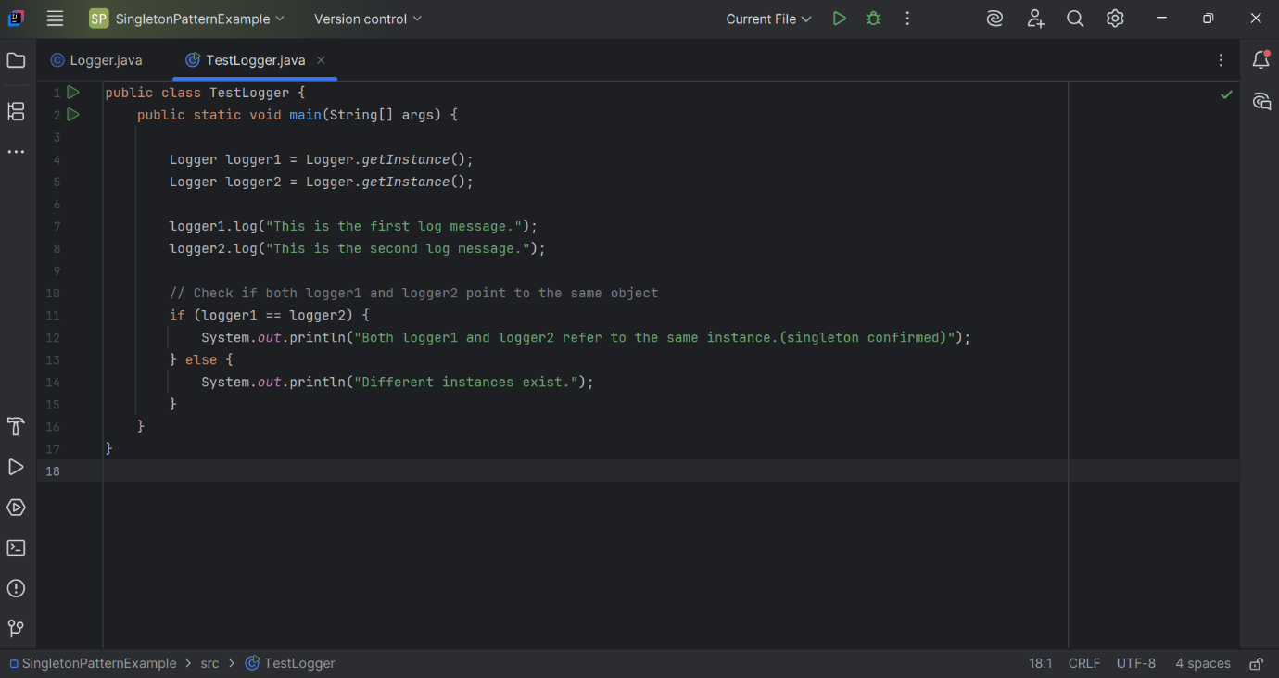

**OUTPUT**

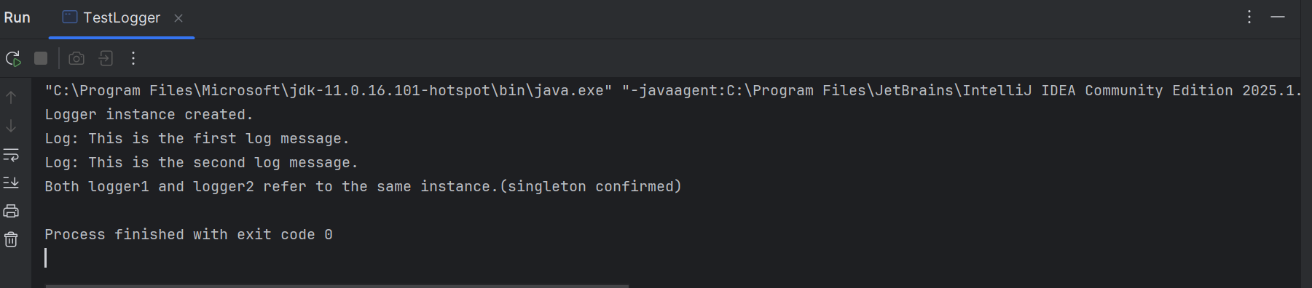

============

**Exercise 2: Implementing the Factory Method Pattern**

**Scenario:**

You are developing a document management system that needs to create different types of documents (e.g., Word, PDF, Excel). Use the Factory Method Pattern to achieve this.

**Steps:**

1. **Create a New Java Project:**
   * Create a new Java project named **FactoryMethodPatternExample**.
2. **Define Document Classes:**
   * Create interfaces or abstract classes for different document types such as **WordDocument**, **PdfDocument**, and **ExcelDocument**.

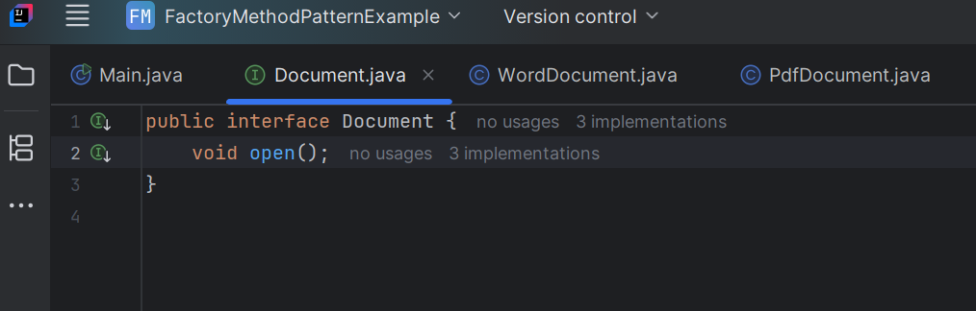

1. **Create Concrete Document Classes:**
   * Implement concrete classes for each document type that implements or extends the above interfaces or abstract classes.

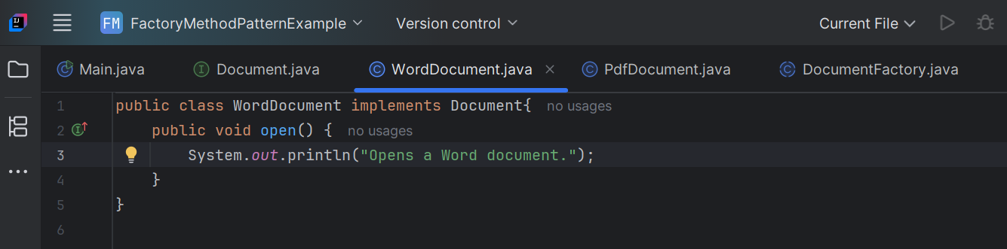

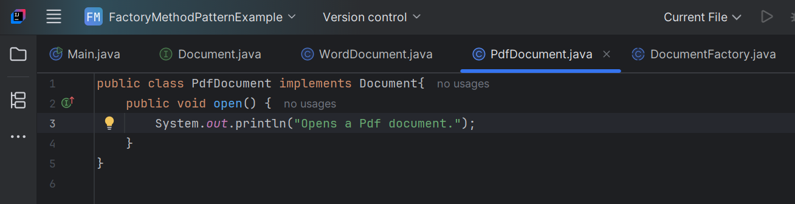

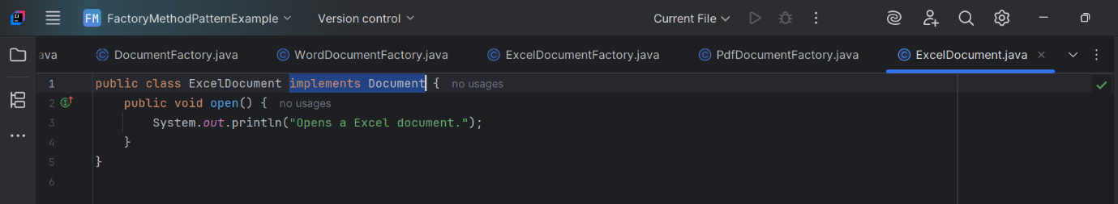

1. **Implement the Factory Method:**
   * Create an abstract class **DocumentFactory** with a method **createDocument()**.

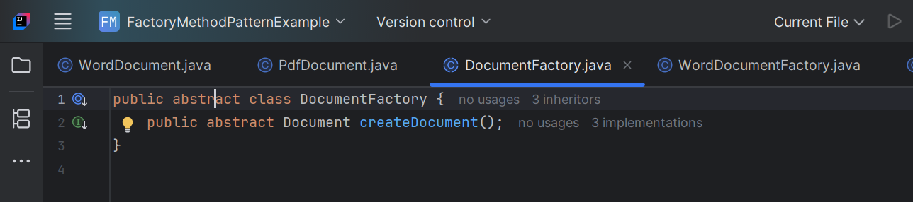

1. Create concrete factory classes for each document type that extends DocumentFactory and implements the **createDocument()** method.

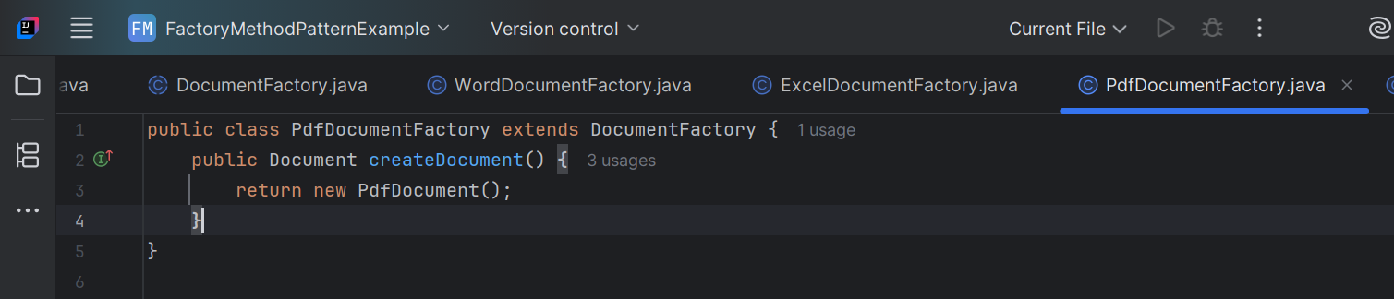

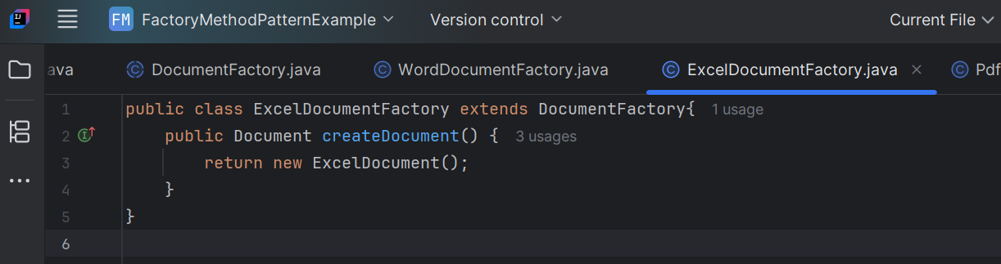

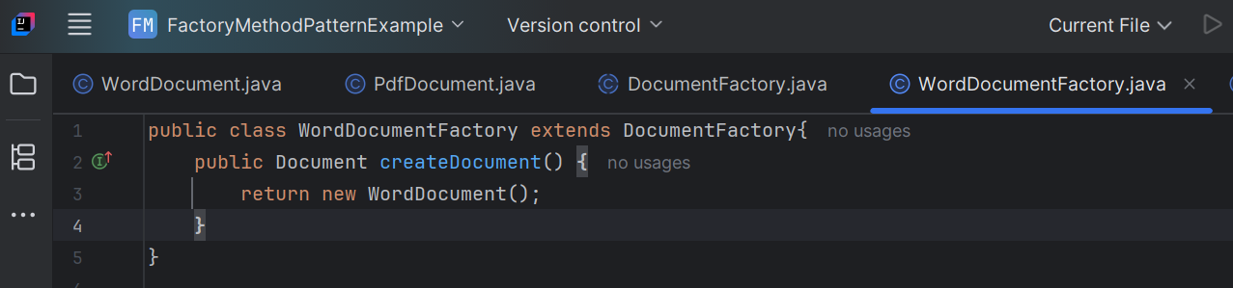

1. **Test the Factory Method Implementation:**
   * Create a test class to demonstrate the creation of different document types using the factory method.

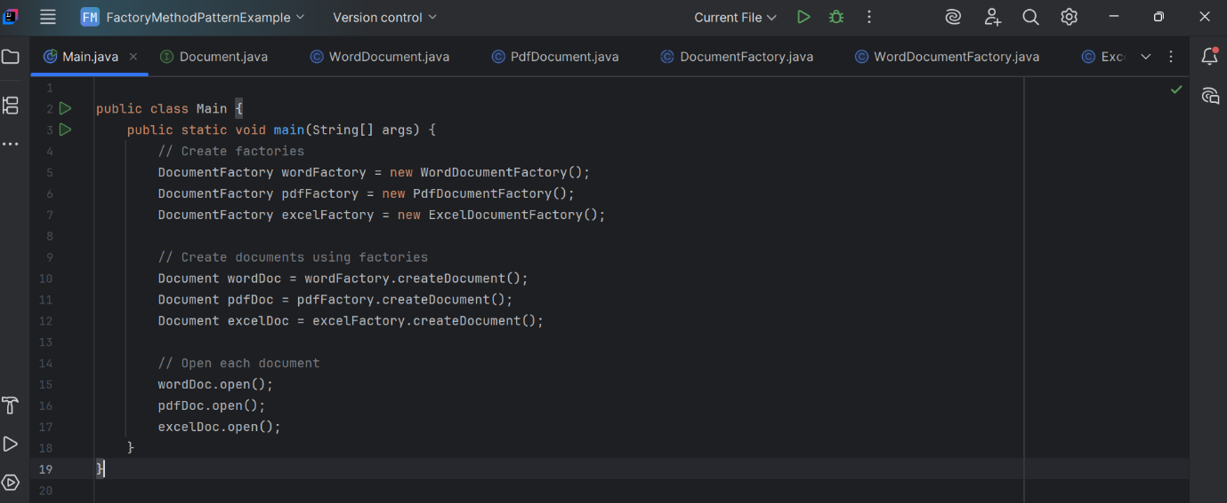

**OUTPUT**

